

Assignment Submitted By

**SABBIR HASAN**

**Reg: 11900603**

**Roll: 04**

Section: KE058

Subject: INT301

Assignment Submitted to   
**Navjot Kaur**

**GitHub Link: https://github.com/Sabbir-Hasan-670/Windows-Missing-Security-With-OpenSource-Software**

**Question Number Allocated:** **41**

**Question:** Using desired Open-Source Software list all the security updates missing in your Window OS. Also, list all free system information about the hardware and software installed.

**1. Introduction:**

**About Software I use:**

Belarc Advisor is a free and comprehensive system information tool that provides detailed information about the hardware and software installed on a computer. It is available for personal and commercial use, and it is compatible with all versions of Windows, including Windows 11.

Belarc Advisor generates a comprehensive system profile that includes information about the operating system, hardware components, installed software applications, security updates, and system vulnerabilities. The tool is easy to use and is useful for identifying potential security vulnerabilities, missing security updates, and hardware or software issues that could impact the performance and security of a computer.

The features of Belarc Advisor include:

1. Detailed hardware and software information - Belarc Advisor provides a detailed inventory of hardware components, such as CPU, memory, motherboard, hard drives, and peripherals, as well as software applications and versions.
2. System security status - Belarc Advisor checks for missing security updates, potential security vulnerabilities, and other security-related issues and provides recommendations to improve system security.
3. Licensing information - Belarc Advisor also provides licensing information for installed software applications, making it easy to manage software licenses.
4. Network information - Belarc Advisor can also scan and provide information about network devices, such as routers and switches, as well as IP addresses and network configurations.

Overall, Belarc Advisor is a powerful and useful tool for conducting a comprehensive system audit, optimizing system performance, and maintaining system security. It is easy to use and is an excellent choice for both home and business users.

**1.1 Object of the Project:**

The main objective of the project with Belarc Advisor is to conduct a system audit to identify potential security vulnerabilities, missing security updates, and hardware or software issues that could impact the performance and security of the system. The project aims to generate a comprehensive system profile using Belarc Advisor to provide detailed information about the hardware and software installed on the system and to use this information to optimize system performance and maintain system security.

**1.2 Project Description:**

The project involves conducting a comprehensive system audit using Belarc Advisor on an individual's own computer. The primary goal of the project is to identify any potential security vulnerabilities, missing security updates, and hardware or software issues that could impact the performance and security of the computer.

**1.3 The scope of the project:**

The scope of the project for your own device would be to conduct a comprehensive system audit using Belarc Advisor to identify any potential security vulnerabilities, missing security updates, and hardware or software issues that could impact the device's performance. The project's objective is to improve the overall security and performance of your device.

**The project's objectives include the following:**

1. Install Belarc Advisor on the individual's own computer.
2. Conduct a system audit using Belarc Advisor to generate a comprehensive system profile.
3. Review the system profile to identify any potential security vulnerabilities, missing security updates, or hardware or software issues.
4. Address any identified vulnerabilities, missing security updates, or hardware or software issues.
5. Conduct periodic system audits to maintain optimal system performance and security.

The project aims to improve the overall security and performance of the individual's own computer, prevent potential data breaches and system downtime, and ensure that the system operates at peak performance. By conducting a system audit using Belarc Advisor, the project aims to provide a comprehensive overview of the computer's status and identify any potential issues that could impact system performance and security, allowing for remediation before any issues become critical.

**2. System Description**

**2.1 Target system description:**

The target system for this project is a laptop computer running Windows 11 Pro. The laptop has a 64-bit processor, 16GB of RAM, a 1TB hard disk, and a 256GB solid-state drive (SSD). The laptop also has a dedicated NVIDIA GeForce GTX 1660Ti graphics processing unit (GPU) with 6GB of video RAM.

The laptop is used for personal or professional purposes and contains various applications and data. The operating system is regularly updated through Microsoft's update mechanism. The laptop is connected to the internet through a Wi-Fi Connection.

**3. Analysis Report:**

**3.1** System snapshots and full analysis report:

For list all free system information about the hardware and software installed I used Belarc Advisor.

First Download and install the Belarc Advisor it give us the information about our software installed in our device and also missing update its show everything.

Gathering Details from the Computer When I Run the software:

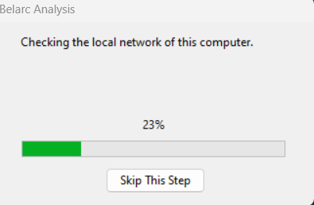

Belarc Advisor is a free system information tool that provides a detailed profile of your installed software, hardware, network inventory, missing Microsoft hotfixes, anti-virus status, security benchmarks, and displays the results in your web browser. Here is a report of Belarc Advisor:

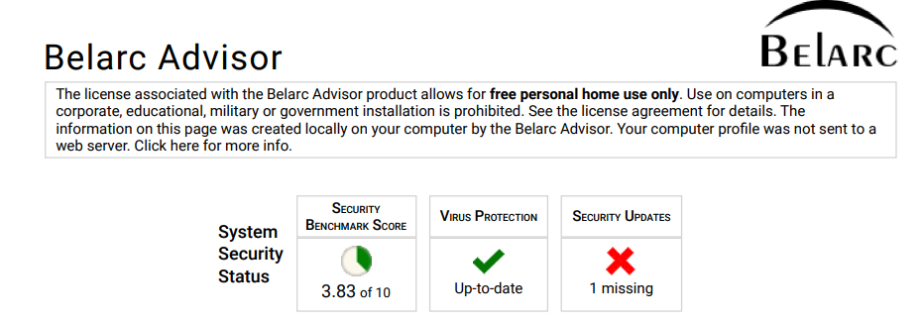

**Security Benchmark Score of my device:**

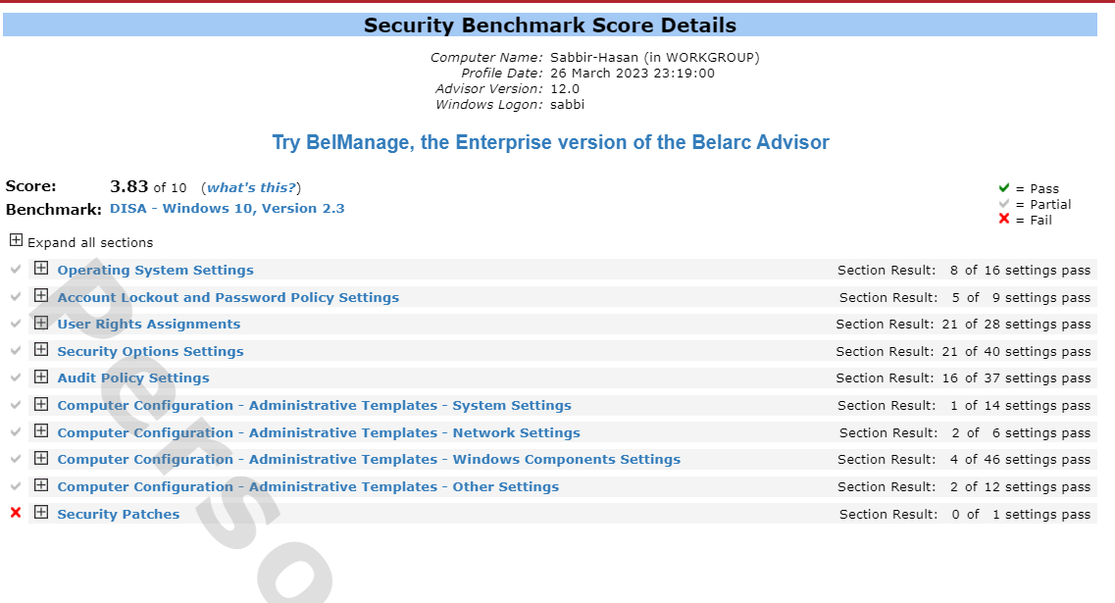

**My system details which are found by Belarc Advisor:**

Understanding system details is crucial for maintaining the optimal performance and security of a computer. Knowing the system specifications and hardware components can help determine if a laptop meets the requirements for specific software applications or upgrades. Understanding the software applications installed on a laptop can also help troubleshoot software-related issues and identify potential security vulnerabilities.

**Missing Security update on my device:**

This report provides an overview of the missing updates identified by Belarc Advisor during system audit of my laptop. The primary objective of the audit was to identify potential security vulnerabilities and missing updates that could impact system performance and security.

**I have only one missing update found on my device. And here it is:**

Hotfixes from Windows Update (agent version 923.203.111.0) install automatically. Last install: 25-03-2023 18:09:23, check: 26-03-2023 15:28:28. These security updates apply to this computer but are not currently installed (using Advisor definitions version 2023.3.15.1), according to the 03/14/2023 Microsoft Security Bulletin Summary and bulletins from other vendors. Note: Security benchmarks require that Critical and Important severity security updates must be installed.

**After Update:**

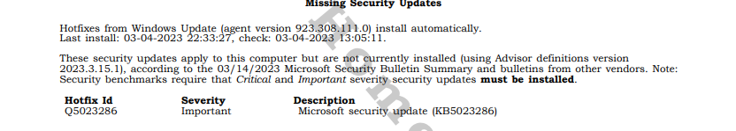

**Impact of Missing Updates:**

Missing updates can have a significant impact on the performance and security of a computer. Security updates are crucial for protecting a computer against potential cyber threats, such as malware and viruses. Missing updates can leave the system vulnerable to cyber-attacks and data breaches, compromising personal and sensitive information.

**Network details on my device:**

This report provides an overview of the network details identified by Belarc Advisor during system audit of my laptop. The audit was to identify network devices, IP addresses, and network configurations.

Here are my all-network details which is found by this software:

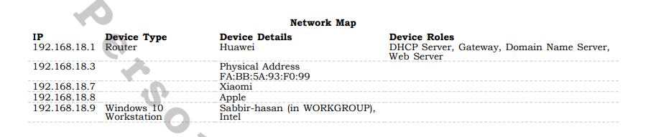

**Impact of Network Details:**

Understanding network details is crucial for maintaining the optimal performance and security of a computer. Knowing the network devices and their configurations can help troubleshoot network issues and optimize network performance. Understanding the network's IP addresses and configurations can also help identify potential security vulnerabilities and prevent cyber threats.

**List of Software installed and their version:**

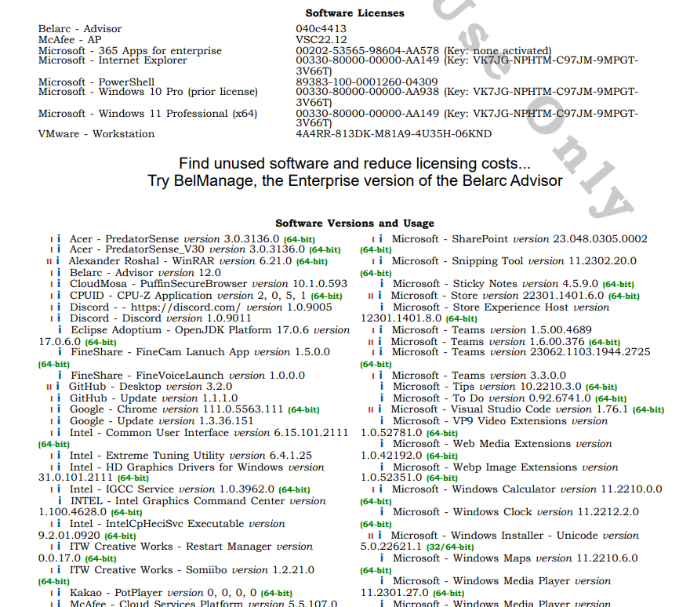

**After Install Some Software:**

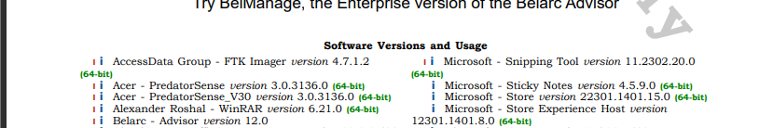

**Conclusion**:

In conclusion, conducting a system audit using Belarc Advisor is an effective way to identify potential security vulnerabilities, missing security updates, and hardware or software issues that could impact system performance. By installing and using Belarc Advisor, you can generate a comprehensive system profile that provides detailed information about the hardware and software installed on your device and system security status.

The scope of the project for your own device includes the installation of Belarc Advisor, conducting a system audit, reviewing the system profile, addressing any identified vulnerabilities or issues, and conducting periodic system audits to maintain the device's security and performance.

Using Belarc Advisor as a tool for conducting a system audit is a proactive step towards improving the overall security and performance of your device, and it can help you to avoid potential issues that could lead to data breaches, system downtime, and other problems.

**4 Reference/ Bibliography**

**Belarc Advisor**: https://www.belarc.com/products/belarc-advisor